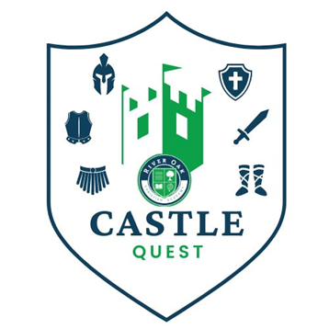
CASTLE QUEST
Fundraiser dates:
September 14 - October 12, 2023

Castle Quest is a student-driven fundraiser competition that raises funds to help bridge the gap between what parents pay for tuition and the true cost of a Christian education. The collective fundraising efforts of the school make up approximately 18% of the school’s budget. Examples include salaries, maintenance, utilities, and tuition assistance. Last year, River Oak students brought in over $38,000 for Castle Wars and River Oak Market Day.

How will Castle Quest work?
Classrooms are on a quest to collect all pieces of their armor. For every $1,000 that is brought in by the class, a piece of armor is earned. Classrooms are working to receive all six pieces of armor for their classroom shield.
The goal is for EACH student to raise $250.

What are the prizes?
CLASSROOM Prize for Earning a Class Piece of Armor:
One piece of class armor = $1,000
- Helmet of Salvation - Choose a Teacher’s Outfit for the Day.
- Breastplate of Righteousness - Special Classroom STEAM time
- Gospel of Peace - Play “silent” ball with Mrs. Smith or Mr. Baker
- Shield of Faith - Movie and Popcorn Party
- Sword of the Spirit- Read-in and Pajama Day
- Belt of Truth - 20-minutes of Extra Recess (KP – 5th grade)
- Belt of Truth - Gimkit Tournament (middle school students)
Classrooms that fill their shield with all six pieces earn the opportunity to create a dress-up or spirit week for the whole school.

STUDENT Prize Options for Earning a Piece of Armor:
One piece of student armor = $250
- Helmet of Salvation - Choose a frozen treat to eat at lunch.
- Breastplate of Righteousness - Personal Popcorn Party
- Gospel of Peace – Earn a Dress Down Day Pass
- Shield of Faith - 20-minutes of Extra Recess
- Sword of the Spirit - Choose something from the prize bucket.
- Belt of Truth - Choose an item from the snack box.
Students that fill their shield with all six pieces will earn a morning to be Principal for the Day!

More Fun!
- Each student that brings in $250 will be invited to a special skate night at SK8 Zone!
- All students raising $500 or more will be given a coupon to enjoy (2) slices of pizzas at the skating party.

How do students collect pledges?
- ASK. This is a student-driven fundraiser, so we encourage you to have your child make the ask. And remember, even small donations can add up!
- Examples of ways to earn money:
  - Class or family yard sale (one class raised $1,400 one year doing this)
  - Lemonade stand
  - Yard or housework for family, friends, or neighbors
  - Facebook videos: Have your child create a video explaining the competition and post it on social media. This has been very successful for students in the last several years.
  - Participate by selling items at a booth at River Oak Market Day on October 7th.
- COLLECT.
- Collect checks and cash yourself: Each student will receive a white envelope with a tracking sheet. Instead of holding onto your pledges and turning them in at the end of the competition, have your child bring the donations to school in the envelope on Thursdays during the competition. The student's envelope will be returned to your child so that more pledges can be collected.
- Online donations: Donations can be received online at: riveroakjc.org/castlequest. Donors can complete and submit the online form. Please remind anyone paying online to include the student's name. Please write on your envelope of any online donation you are expecting the school to receive. This will help us track and look for the payment coming in and give your student credit for the donation.
- By mail: Donors can mail checks to: River Oak Christian Academy, 919 Wildwood, Jefferson City, MO 65109. Please ask donors to include a note with your child's name.
- Only monies received and turned in by 12:00 p.m. on October 12, 2023, will only be counted for prizes, pledges do not count.
Questions?
Contact: Lisa Smith at 573.634.3983 or email lisa.smith@riveroakjc.org
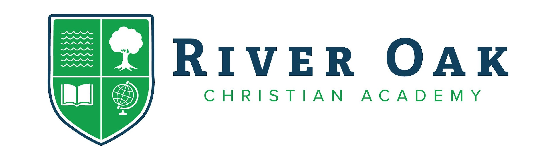

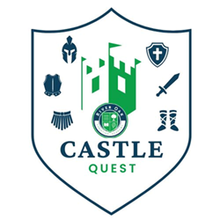

ROOTED IN FAITH. GROWING IN KNOWLEDGE.
919 Wildwood, JEFFERSON CITY, MO 65109 | 573.634.3983 | RIVEROAKJC.ORG

